INF 1103 Lab 3 Submission:
1: Python file (modular_auditor.py) ✅
2: Git Log:
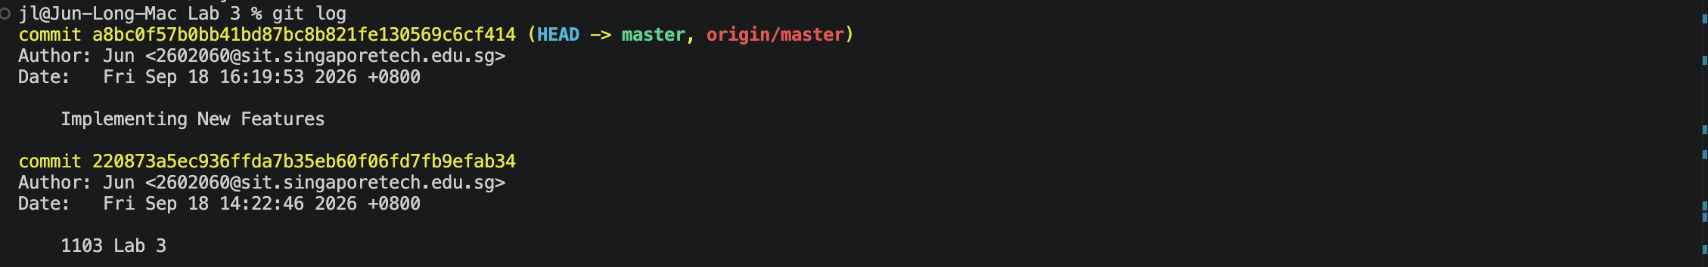
3: Docker Mount and Run:
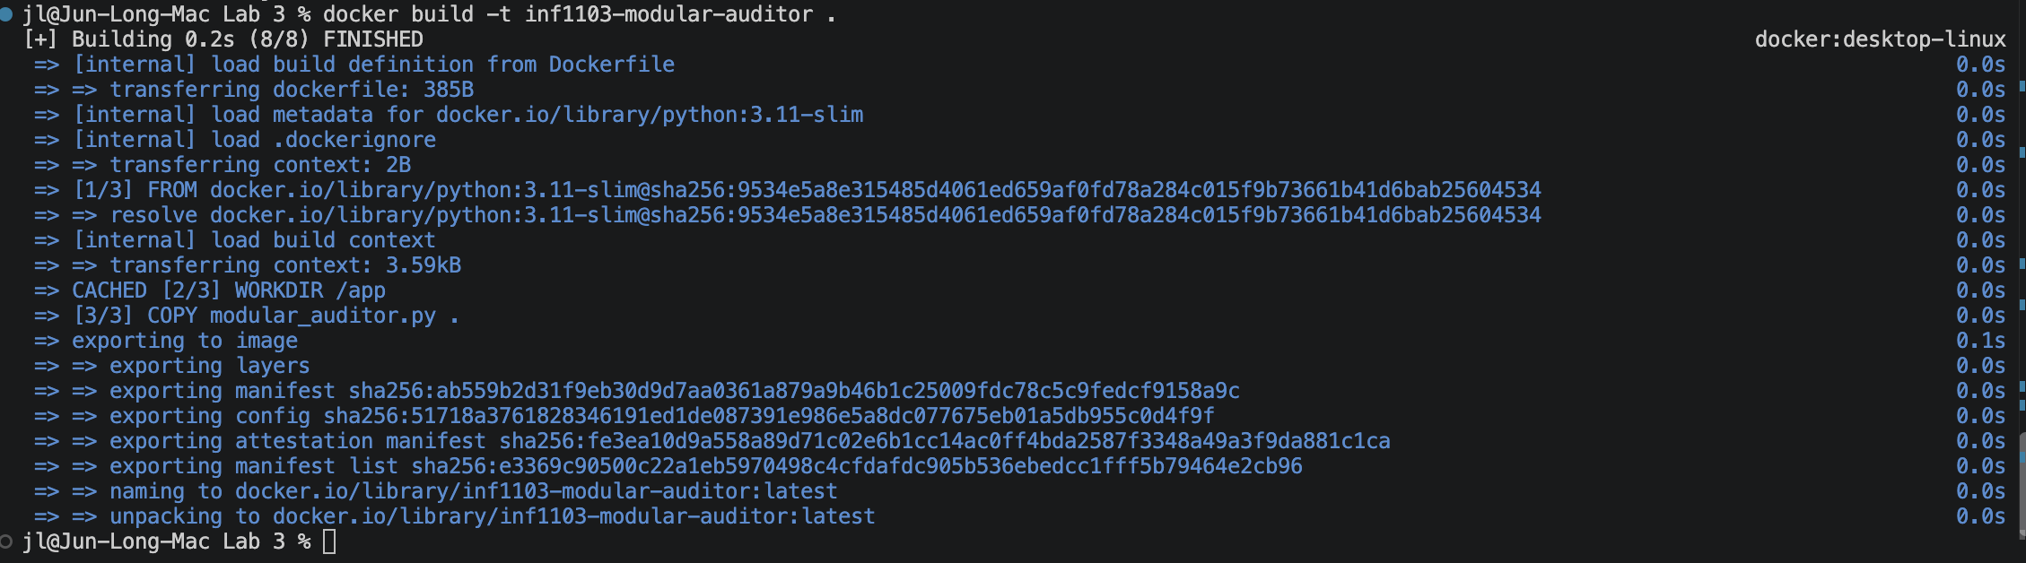
4: Evidence of image successfully built:

5: Proof of my modular_auditor.py run successfully by accepting input and producing results.
